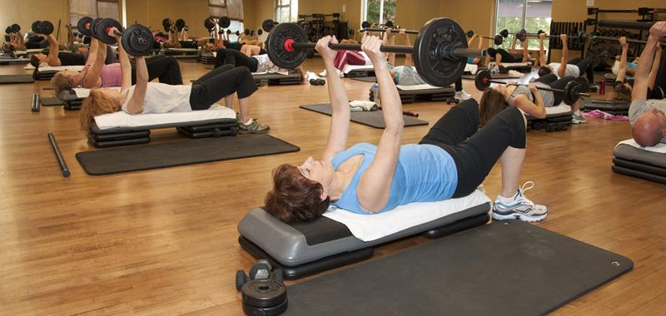

Class | Monday | Tuesday | Wednesday | Thursday | Friday | Saturday
 | 12:00-1:00pm  Gym | 5:30-6:30pm  Gym | 12:00-1:00pm  Gym | 5:30-6:30pm  Gym | 12:00-1:00pm  Gym
 | 6:30-7:30pm  Dance Studio |  | 6:30-7:30pm  Dance Studio |  |  | 8:00-9:00am  Dance Studio
 |  | 7:15-8:15pm  Dance Studio |  | 7:15-8:15pm  Dance Studio
 |  | 12:05-12:55pm  Dance Studio |  | 12:05-12:55pm  Dance Studio
JAZZERCISE
Class | Monday | Tuesday | Wednesday | Thursday | Friday | Saturday
 |  | 7:05-7:50pm  Banquet Hall | 7:05-7:35pm  Banquet Hall
$5/Class for pass holders |  |  |  |  |  | 9:15-10:15am  Dance Studio
$5/Class for pass holders | 7:50-8:50am  Social Hall  6:05-7:05  Banquet Hall | 6:05-7:05pm  Banquet Hall | 7:50-8:50am  Social Hall  6:05-7:05  Banquet Hall | 6:05-7:05pm  Banquet Hall
Schedule is subject to change. Published 2/1/18

